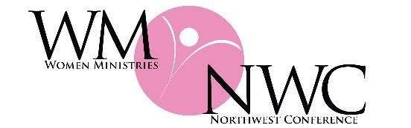
Women Ministries exist to advance God’s kingdom through women---by connecting them in transformational relationships
and by uniting them in Christ to impact our world.

Memorial Gift Donation

The enclosed gift of ___________ is given to Women Ministries of the Northwest Conference

in memory of _________________________________________ or

in honor of (person or special occasion)____________________________________

Please use this gift to further the work of Women Ministries of the Northwest Conference.

Designation: Greatest Need___________________________ or
Specific Ministry___________________________

Please send an acknowledgement to:
Name:__________________________________________

Family of: ____________________________________________________________________

Address: ____________________________________________State __________ Zip: ______

Please send a receipt to:
Name: ___________________________________________________

Church/Group/Business: _________________________________________________________

Address _________________________________ City ____________Sate ______ Zip________

Thank you for honoring your loved one with this gift to further the work of Women Ministries of the Northwest Conference of the Evangelical Covenant Church.

